Working Sheet for instructors
- Review assignment instructions and marking criteria. Then ask your instructors if you have any questions.
Rules and regulation for essay writing and submission:
- Plagiarism | 10% maximum allowed but will affect your grade. More than 10% is considered cheating and will lose total marks.
- Number of words | At least 1000 words excluding references
- Submission date and time | 12-12-2020 @ 12 pm
- Submission technique | Word file uploaded in the blackboard.  Pdf are not allowed.
- Essay font type, color and size. | Times romans, black, size 12.
- Referencing style | Vancouver style and citation manager is recommended.
Marking criteria:
ODE | Ideas and content |  | Organization | Convention | Timely Submission and format
 | Focus/ Depth | Evidence evaluation | Organizational structure | Language mechanics/ vocab | Timely Submission and format
Exceeds  8 grades | 1- The main idea was focused & maintained.  2-The essay answers the question.  3- The main idea was thoroughly supported.  4-The response has considerable depth & relevant. | 1-Evidence was of high quality, adequate quantity well discussed.  2- Adequate citation, accurate referencing style & Authentic content. | 1-The essay structure is clear, organized, & coherent.  2-The ideas progression is smooth and relevant in paragraphs and sentences. | 1-Correct use of capitalization and punctuation, & spelling.  2-Less than three grammatical or expression mistakes.  3-Adequate use of vocabulary. | 1-Submit on time.  2-Follow instruction accurately.  3-Adequate format and presentation.  4-There is a significant increase in the number of words. (100 words more than required)
Meets  6 grades | 1-The main idea was mentioned & maintained.  2- The essay answers the question.  3-The main idea was elaborated & supported. Might lack depth or creativity. | 1-Evidence is of moderate quality & quantity.  2- Accurate citation & referencing style.  3- Authentic content. | 1- The essay has an organized structure. May lack clarity in one paragraph passage only.  2-The content is connected and is progressing adequately. | The student has less than 5 mistakes in total (grammar, capitalization, punctuation, vocab, spelling, or expression) | 1-Submit on time.  2-Follow instruction accurately in format and presentation.  4-Number of words was met or slightly exceeded.
Nearly meets  4 grades | 1-The main idea was mentioned but not maintained.  2-The essay answers the question partially.  3-Inadequate support to the main idea. | 1-Evidence is irrelevant or week.  2-Inaccuracy in citation & referencing style.  3-Less than 5% plagiarism. | 1- Irregular organization. May lack clarity in two paragraph passages.  2-Week use of connectors or uneven progression of ideas. | The student has less than 10 mistakes in total. | 1-One day delay.  2-Instruction was followed with few mistakes (80%).  3-Number of words is up to 50 words less than required.
Working towards  2 grade | 1-The main idea was not mentioned or lost.  2-The essay question was not answered.  3-Brief response. | 1-Absence of Evidence.  2- Less than 10% plagiarism. | 1- Unclear and confusing content.  2- Incoherent or irrelevant ideas.  3-Misuse of connectors. | The student has more than 10 mistakes in total. | 1-Two days delay.  2-Instruction was followed (50%).  3-Number of words is up to 100 words less than required

Steps for writing the essay with an example:
- Analyze your title/ question: (write the following the subject, the focus, the scope, the instruction word.)
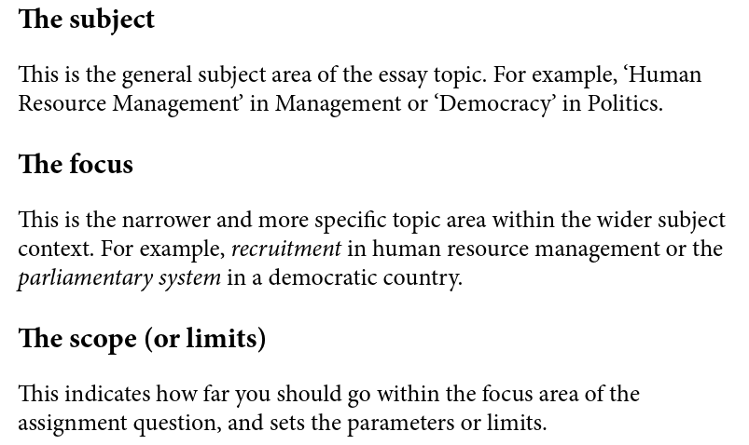
e.g. Discuss dental implication of diabetes mellitus (the subject)
The focus: (dental implication)
The scope: (diabetes mellitus)
Instruction word: discuss (means: talk or write about (a topic) in detail, taking into account different issues or ideas.)
- Generate your questions:
They should write at least 5 primary question in regard their topic
For example: Discuss dental implication of diabetes mellitus.
What is diabetes mellitus?
What types of diabetes mellitus?
Why does the diabetes mellitus affect the body function?
How is the diabetes mellitus treated?
What are the implication of diabetes mellitus in dentistry?
(Implications include possible drug interactions with local anesthesia, analgesics, and antibiotics. Possible interferences with dental surgery or wound healing. Periodontal disease and periapical lesions.)

- Make your provisional plan using fishbone essay plan template.
Organize the questions in the fishbone template.
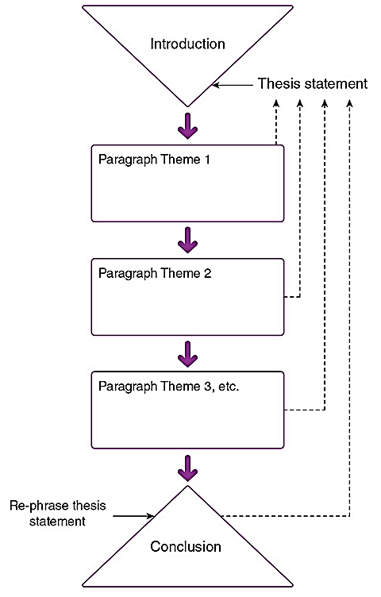
Summarize – emphasize – future recommendation or closing statement.
- Oral manifestation.

- Possible drug interactions in dentistry

- Dental surgery and wound healing.

- Management of dental infection.

What is diabetes mellitus?
What types of diabetes mellitus?
Why does the diabetes mellitus affect the body function?
How is the diabetes mellitus treated?
What are the implication of diabetes mellitus in dentistry
( remember hook –define difficult terms- background – statement of purpose)

- Research the questions using searching engine.
Advice students in finding answers in suitable literature reviews or systemic reviews.

